|  |  |
| --- | --- |
| A picture of a winding road and trees  WEDE-POE  Updated Process Document | Abstract  This a proposal document describing my website for my small business that I just started  Kwaito Junior Lawrence Mbuyane-ST10496345  Web Development |

# TABLE OF CONTENT

**Cover Page**  ……………………………………………………………………………….**1**

**Table of Contents …**…………………………………………………………………………….**2**

**Introduction** …………………………………………………………………………….….**3**

**Home Page** ……………………………………………………………………………….**4-5**

**About Page** ………………………………………………………………………………...**6**

**Contact us Page** ………………………………………………………………………………...**7**

**Services Page** …………………………………………………………………………………**8**

**Pictures** …………………………………………………………………………………**5,9-12**

**References** …………………………………………………………………………………**14**

**MY WEBSITE: RAW-FITNESS**

I have designed a website for my new small fitness business, the title of my business is called “Raw-Fitness” accompanied by the slogan “Unleash your strength. Elevate Your Game”. It is simple user-friendly website, easy to navigate and engages with the fewer with the use of captivating pictures and ecstatic interface, giving you an amazing customer experience.

**HOME PAGE**

A HOME PAGE is the main page of your website which serves as an introduction to your brand and your products and services (themeisle, 2023).

My HOME PAGE consist of:

* A simple navigation bar at the top right corner and a display of our logo and slogan at the top left corner of our HOME PAGE
* A footer with a copy-right’s tag at the bottom of our HOME PAGE which is constant throughout the website(,it is important to include a footer in your website as it provides you with useful information and can also act as an anchor point signalling to the viewer that they have reached the bottom of the page (Lugg, 2024) )
* It has a simple-structured layout that is appealing to our viewers with a dim background photo to accommodate our light sensitive viewers.
* You will be met with a welcome message upon entering our homepage

(Projects, n.d.)

Figure 1 My logo

(Choquette, n.d.)Picture of the logo and the slogan


Figure 2 background photo of my website

**ABOUT PAGE**

An ABOUT US page is important as it is a chance to introduce your business to the public ,telling them what your business is about and more (Ritenour, 2022) .The ABOUT PAGE of my website offers detailed information about the business regarding our vision and mission while also highlighting some of the most beneficial reasons for keeping in-shape, which can be read as follows:

(Arlene Semeco, 2023)

* Can be a good stress reliever, keeping you in a good mood
* Assists in weight management
* Contributes to your bone and muscle growth
* Increases your energy levels
* Plays a major role in lowering the risk of chronic diseases
* Keeps your skin clean
* Helps keep your brain healthy and improving your memory
* Improves sleep quality
* Reduces pain
* And can also improve your sex life

OBJECTIVES

* Inspire Hope
* Improve one’s self-image
* Lower the suicide rate led by low-self esteem
* Lower the obesity rate
* Lower the rate of chronic illnesses

ACHIEVING ALL OF THE ABOVE WHILE MAKING PROFIT IN THE PROCESS

TARGET AUDIENCE

Anyone who’s looking to lose weight or stay in -shape any of the two it doesn’t matter top us, we accommodate anyone who wants to better themselves and improve their self-image

**CONTACT US**

A CONTACT US page is important for a website as it helps forge a relationship between the company and the customer, builds trust, prevents spams, answers question and gives your customers an incentive to part their cash (The Importance of Your Contact Page, 2018) .

My contact page includes the following:

* Our email address
* Our phone number
* Our physical address

Photographs of key contact people

**SERVICE PAGE**

A service page is the page where you can find the list and description of services that your business offers (How To Write Service Page Content: 15 Tips, Examples And An Infographic, 2022)

Our SERVICES PAGE includes the following services:

* Health Professionals
* Personal Trainers (These are experts that highly qualified and specialise in various fields from weight loss, muscle gain, functional fitness and sport-specific training)
* Boxing Classes
* Cycle classes
* Pilates
* Yoga classes
* Dance classes

(Popovich, n.d.)



Figure 3 Picture for our boxing service classes template

(Ustaosmanoglu, n.d.)

Figure 4 A picture of our health professionals service template

(Shrkaba, n.d.)

Figure 5 picture of our professional trainers’ services’ template

(Borba, n.d.)

Figure 6 Picture of our Cycle classes services’ template

(Piacqaudio, n.d.)



Figure 7 picture of our Pilates service’s template

(krukau, n.d.)

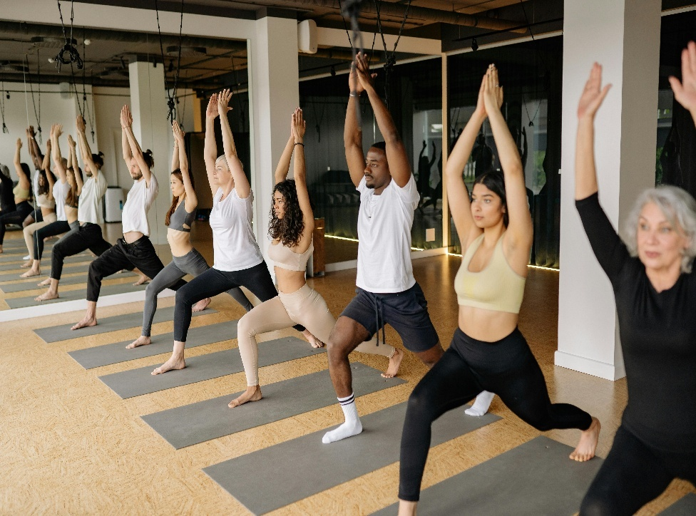

Figure 8 picture of our yoga service's template

(Zittel, n.d.)



Figure 9 picture of our dance classes service’s template

**REFERENCES**

# References

Arlene Semeco, M. R. (2023, November 13). Retrieved from Healthline: https://www.healthline.com/nutrition/10-benefits-of-exercise

Borba, J. (n.d.). *Photos*. Retrieved April 04, 2025, from Canva: https://www.pexels.com/photo/man-in-black-tank-top-and-black-shorts-riding-on-motorcycle-13896068/

Choquette, W. (n.d.). *Photos*. Retrieved from pixels: https://www.pexels.com/photo/an-on-treadmill-1954524/

*How To Write Service Page Content: 15 Tips, Examples And An Infographic*. (2022, February 15). (J. Forrest, Producer) Retrieved April 04, 2025, from CopyWritting Crew: https://copywritingcrew.com/how-to-write-service-page-content-15-tips-examples-and-an-infographic/#:~:text=What%20is%20a%20service%20page%3F%20A%20service%20page,a%20short%20description%20for%20each%20of%20the%20services.

krukau, Y. (n.d.). *Photo*. Retrieved April 04, 2025, from Canva: https://www.pexels.com/photo/people-doing-raised-hands-pose-in-yoga-class-8436587/

Lugg, L. (2024). The importance of a great website footer. *SUSPIREMEDIA*. Retrieved April 03 , 2025, from https://www.suspiremedia.co.uk/news/news-posts/the-importance-of-a-great-website-footer/

Piacqaudio, A. (n.d.). *Photos*. Retrieved April 04, 2025, from Canva: https://www.pexels.com/photo/group-of-woman-doing-yoga-868483/

Popovich, A. (n.d.). *Photos*. Retrieved April 04 , 2025, from Canva: https://www.pexels.com/photo/bout-in-boxing-ring-14898673/

*Projects*. (n.d.). Retrieved from Canva: https://www.canva.com/projects

Ritenour, K. (2022, October 12). *What is an about page and why does it matter?* Retrieved from Web Startegies: https://webstrategies.com/what-is-an-about-page-and-why-does-it-matter/

Shrkaba, A. (n.d.). *Photos*. Retrieved April 04, 2025, from Canva: https://www.pexels.com/photo/photo-of-woman-smiling-while-holding-green-exercise-ball-4662359/

*The Importance of Your Contact Page*. (2018, October 23). (Weatherburn) Retrieved April 04, 2025, from theclickhub: https://theclickhub.com/importance-website-contact-page/

themeisle. (2023, June 11). *What Is a Homepage (in Website)?* Retrieved from Themeisle: https://themeisle.com/blog/homepage-in-website/

Ustaosmanoglu, F. (n.d.). *Photo*. Retrieved April 04, 2025, from Canva: https://www.pexels.com/photo/chiropractor-with-model-of-spine-19440815/

Zittel, M. (n.d.). *Photos*. Retrieved April 04, 2025, from Canva: https://www.pexels.com/photo/people-inside-room-12312/